**Assignment 17.1**

**Problem Statement:**

Write a program that accepts the job_id as argument and returns a custom counter and a system counter (total records input to the map tasks) associated with that job.

**Program:**

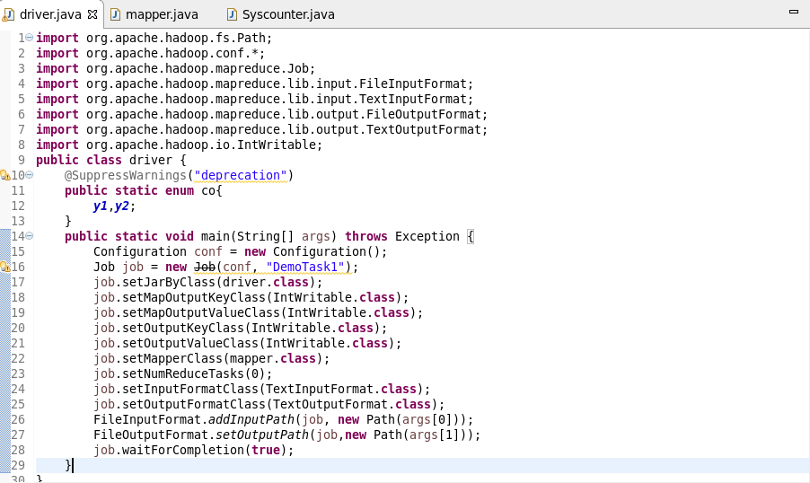

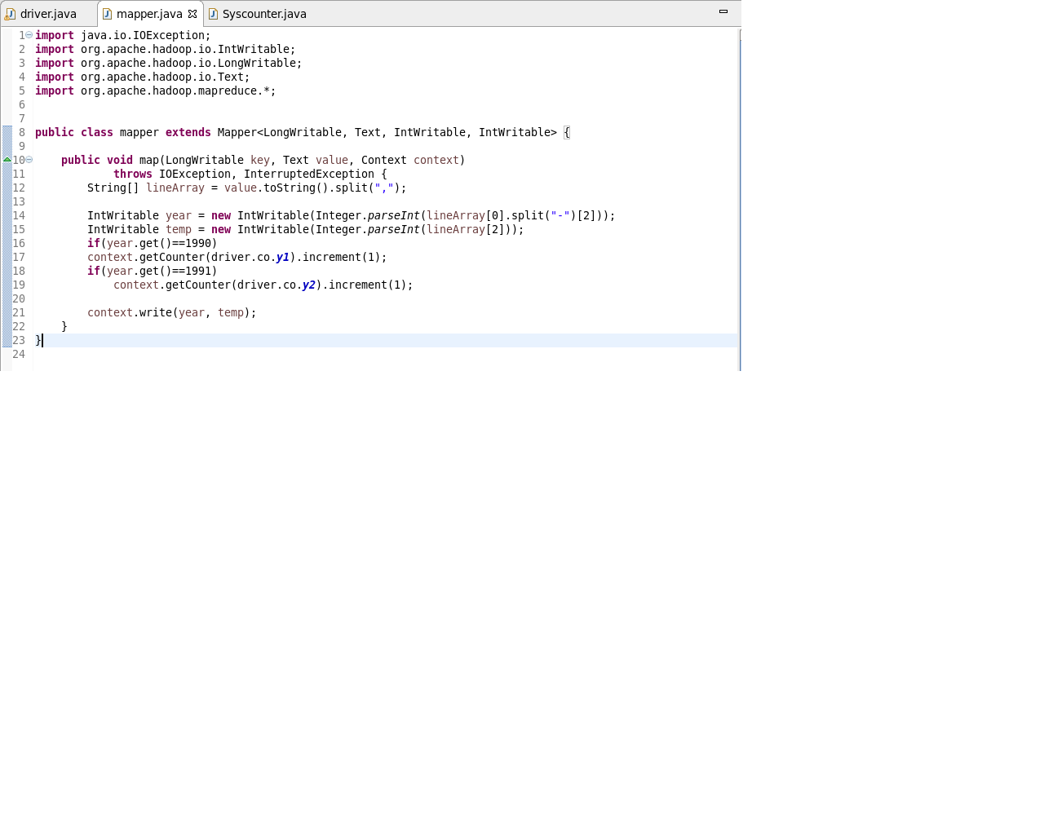

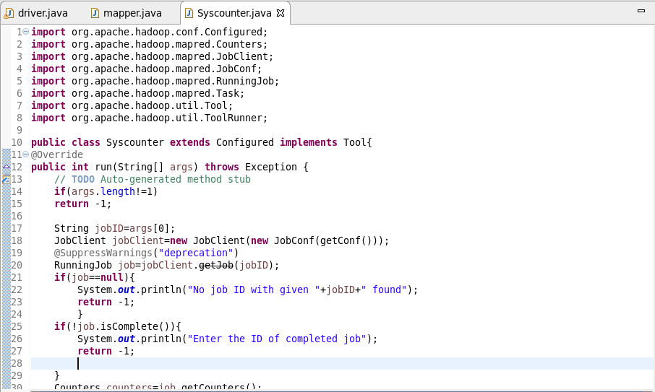

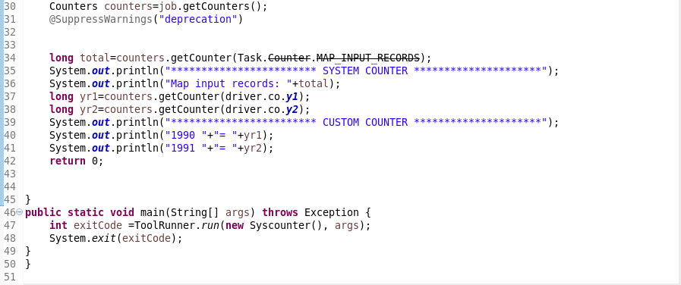

In the above class we accept job ID as input and display system counter and custom counter for the same job.

**Output:**

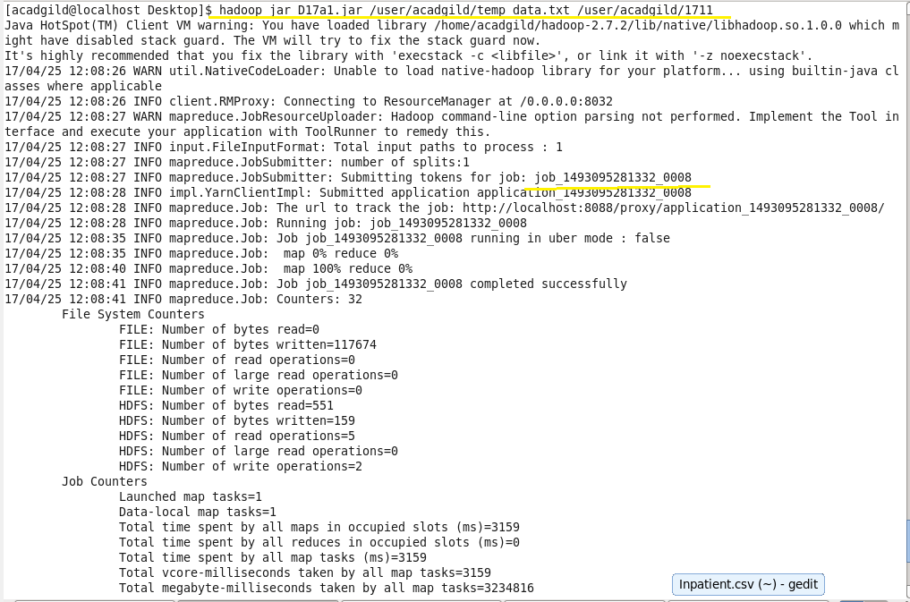

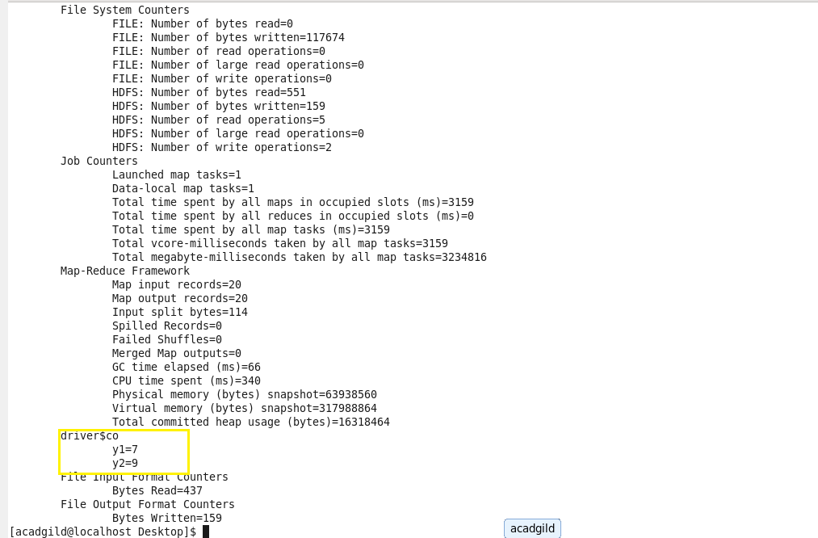

We can see the custom counter in job history as below:

